
North Bengal International University

Lab Report: 06
Exp Name : A program to implement of stack in c program .

Subject : Data Structure
Subject Code : CSE 0612-2131

Submitted By:
Name : Md. Tanvir Rahman Pranto
Dept : CSE
Roll : 0712340012101005
Semester : 2nd Year, 4th semester.

Submitted To:
Name : Saifur Rahman
Designation : Lecturer
Dept : CSE
Date :

Code:
#include <stdio.h>
#define SIZE 5

int main() {
int stack[SIZE], top = -1, choice, x, i;

while (1) {
printf("\n1. Push\n2. Pop\n3. Display\n4. Exit\nChoose: ");
scanf("%d", &choice);

if (choice == 1) {
if (top == SIZE - 1) {
printf("Stack is full!\n");
} else {
printf("Enter element to push: ");
scanf("%d", &x);
top++;
stack[top] = x;
printf("%d pushed into stack.\n", x);
}
} else if (choice == 2) {
if (top == -1) {
printf("Stack is empty!\n");
} else {
printf("%d popped from stack.\n", stack[top]);
top--;
}
} else if (choice == 3) {
if (top == -1) {
printf("Stack is empty!\n");
} else {
printf("Stack elements: ");
for (i = 0; i <= top; i++) {
printf("%d ", stack[i]);
}
printf("\n");
}
} else if (choice == 4) {
printf("Exiting...\n");
break;
} else {
printf("Invalid choice! Try again.\n");
}
}

return 0;
}

Output:

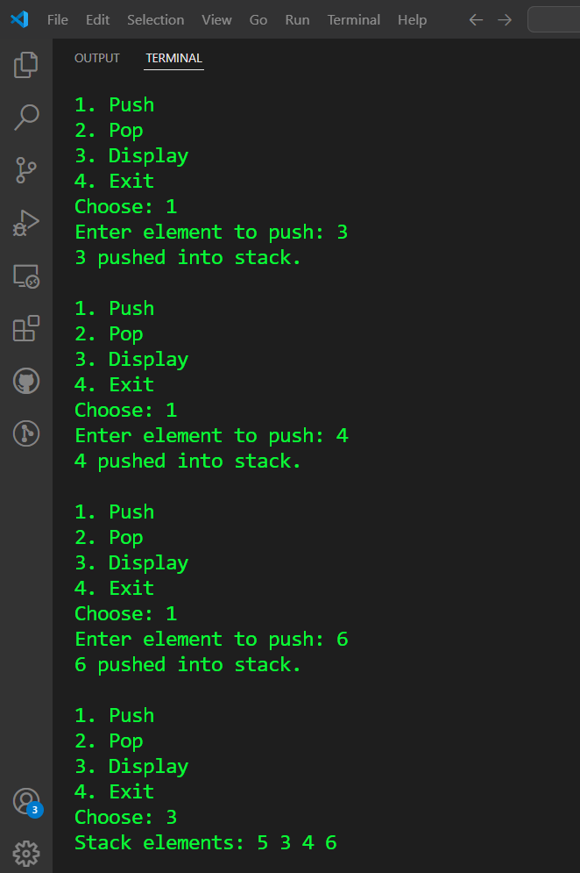

Conclusion: This program implements a stack using an array, allowing elements to be pushed, popped, and displayed interactively. It follows a basic approach, making stack operations easy to understand for beginners

